Spring Cloud Local Deployer

Spring Cloud DataFlow可以deploy到local模式下，部署步骤如下：

1. 下载安装包

*wget https://repo.spring.io/release/org/springframework/cloud/spring-cloud-dataflow-server-local/1.5.2.RELEASE/spring-cloud-dataflow-server-local-1.5.2.RELEASE.jar*

*wget https://repo.spring.io/release/org/springframework/cloud/spring-cloud-dataflow-shell/1.5.2.RELEASE/spring-cloud-dataflow-shell-1.5.2.RELEASE.jar*

1. 启动

* 启动dataflow server

*java -jar spring-cloud-dataflow-server-local-1.5.2.RELEASE.jar*

日志输出如下：

*Spring Cloud Data Flow Local Server (v1.5.2.RELEASE)*

*Started LocalDataFlowServer in 83.765 seconds (JVM running for 86.756)*

* 启动dataflow shell(在相同主机上，启动如下)

*# java -jar spring-cloud-dataflow-shell-1.5.2.RELEASE.jar*

输出日志如下：

*welcome to the Spring Cloud Data Flow shell. For assistance hit TAB or type "help".*

*dataflow:>*

1. 部署Deploy Streams

默认情况下application registry中没有应用，首先要注册应用

*dataflow:>app register --name http --type source --uri maven://org.springframework.cloud.stream.app:http-source-rabbit:1.2.0.RELEASE*

*Successfully registered application 'source:http'*

*dataflow:>app register --name log --type sink --uri maven://org.springframework.cloud.stream.app:log-sink-rabbit:1.1.0.RELEASE*

*Successfully registered application 'sink:log'*

*查询如下*

*dataflow:>app list*

*╔══════╤═════════╤════╤════╗*

*║source│processor│sink│task║*

*╠══════╪═════════╪════╪════╣*

*║http │ │log │ ║*

*╚══════╧═════════╧════╧════╝*

已经注册了stream中的http和log两个应用，创建Stream，步骤如下：

*dataflow:>stream create --name httptest --definition "http --server.port=9000 | log" --deploy*

*Created new stream 'httptest'*

*Deployment request has been sen*

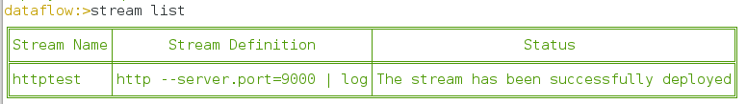

查看本地启动进程如下：

*# jps*

*4848 http-source-rabbit-1.2.0.RELEASE.jar*

*4833 log-sink-rabbit-1.1.0.RELEASE.jar*

4848启动端口为server.port为9000

*# netstat -anp|grep 4848*

*tcp6 0 0 :::9000 :::* LISTEN 4848/java*

查看Data Flow端日志

*Deploying app with deploymentId httptest.log instance 0. Logs will be in /tmp/spring-cloud-deployer-2728833519769910142/httptest-1531921603762/httptest.log*

*Deploying app with deploymentId httptest.http instance 0. Logs will be in /tmp/spring-cloud-deployer-2728833519769910142/httptest-1531921613916/httptest.http*

向启动的server发送post请求

*dataflow:>http post --target http://localhost:9000 --data "hello world"*

*> POST (text/plain) http://localhost:9000 hello world*

*> 202 ACCEPTED*

查看http log，查看spring dataflow server的log，可以定位到启动的log文件，如下所示：

*[http.httptest-1] log-sink : hello world*

查看RabbitMQ，可以获取看到topic

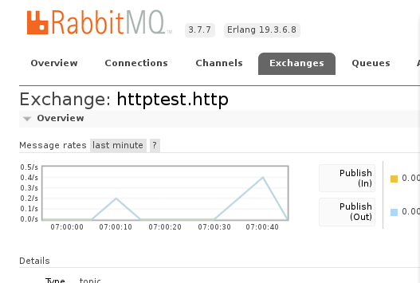

1. 部署Task，其执行流程和Stream相同

* 注册Task App

*dataflow:>app register --name timestamp --type task --uri maven://org.springframework.cloud.task.app:timestamp-task:1.3.0.RELEASE*

*Successfully registered application 'task:timestamp'*

* 创建Task Definition

*dataflow:>task create --name printTimeStamp --definition "timestamp"*

*Created new task 'printTimeStamp'*

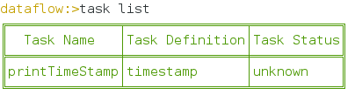

* 启动Task

*dataflow:>task launch printTimeStamp*

*Launched task 'printTimeStamp'*

在Server中执行如下：

*Command to be executed: /root/soft/jdk1.8.0_161/jre/bin/java -jar /root/.m2/repository/org/springframework/cloud/task/app/timestamp-task/1.3.0.RELEASE/timestamp-task-1.3.0.RELEASE.jar --spring.cloud.task.executionid=1*

*launching task printTimeStamp-0e42d0ee-634f-4f16-bcb1-7753b49a304f*

*Logs will be in /tmp/printTimeStamp7290860913353093080/1531923537663/printTimeStamp-0e42d0ee-634f-4f16-bcb1-7753b49a304f*

在Task日志如下：

*TimestampTaskConfiguration$TimestampTask : 2018-07-18 07:19:23.49*

*Started TimestampTaskApplication in 24.133 seconds*

* 查看Task的执行

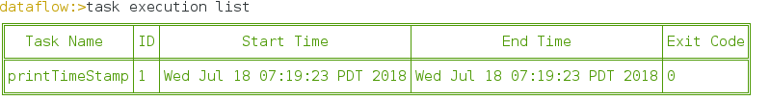

查看Task执行状态

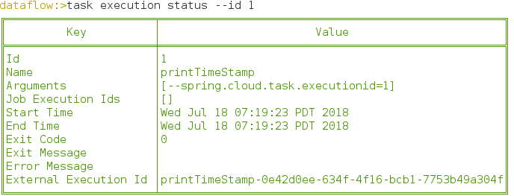

https://github.com/spring-cloud/spring-cloud-deployer

https://github.com/spring-cloud/spring-cloud-deployer-local/tree/master/spring-cloud-deployer-local

https://docs.spring.io/spring-cloud-dataflow/docs/current/reference/htmlsingle/#_simple_task_launch